HOME PAGE
LOGO Social media | Sign in | Register

Home | BSC IT (dropdown) | Assessment: (Tests, quizzes, assignments with automated grading) | Analytics (reporting) |other (About/contact us/help)

Banner

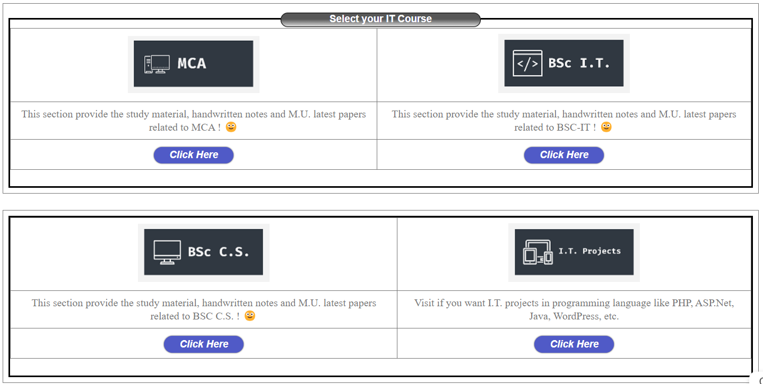

Footer
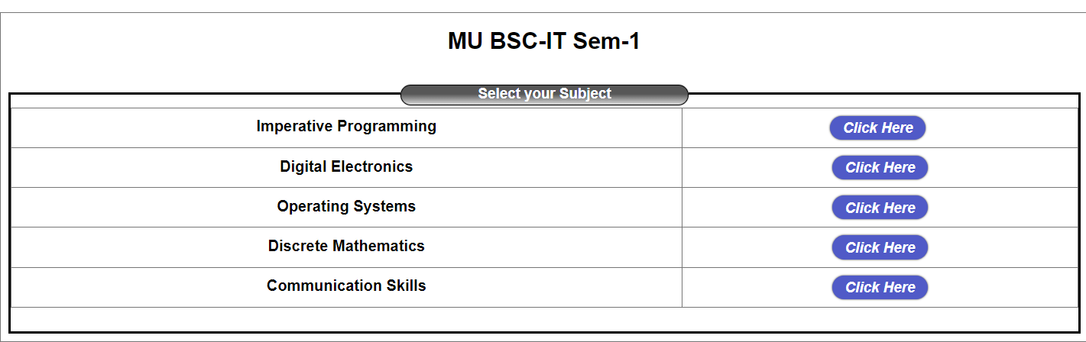
Footer
BSC IT (BSCIT | BSCCS) PAGES
Sem 1 Sem 1
Sem 2 Sem 2
Sem 3 Sem 3
Sem 4 Sem 4
Sem 5 Sem 5
Sem 6 Sem 6

SAME AS FOR ALL SEM and with subject At other other page BSCIT and CS
Assessment PAGES: (Tests, quizzes, assignments with automated grading)
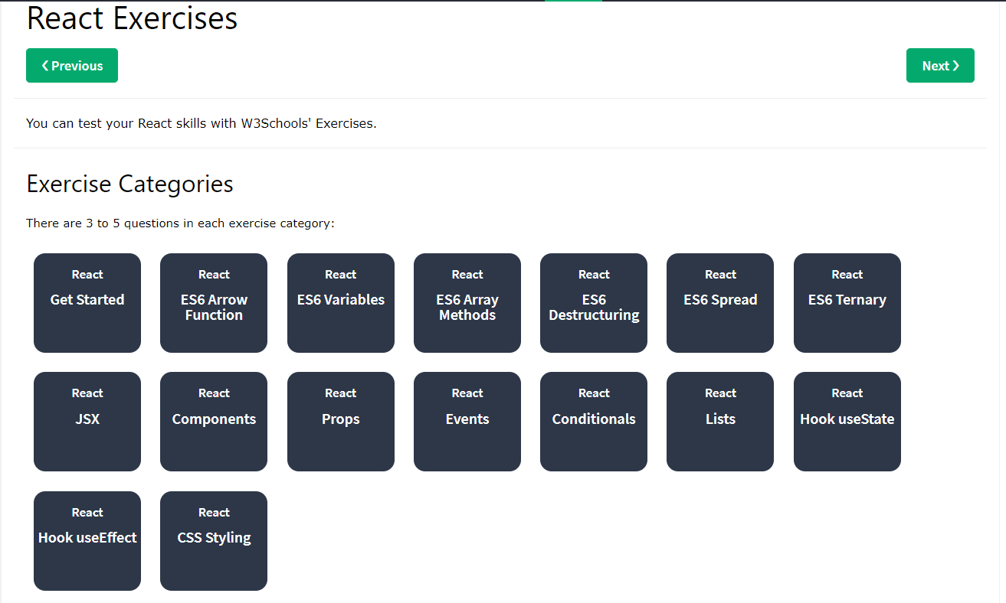
AT the end Topic wise scrore rate provide

Other PAGE (About/contact us/help)
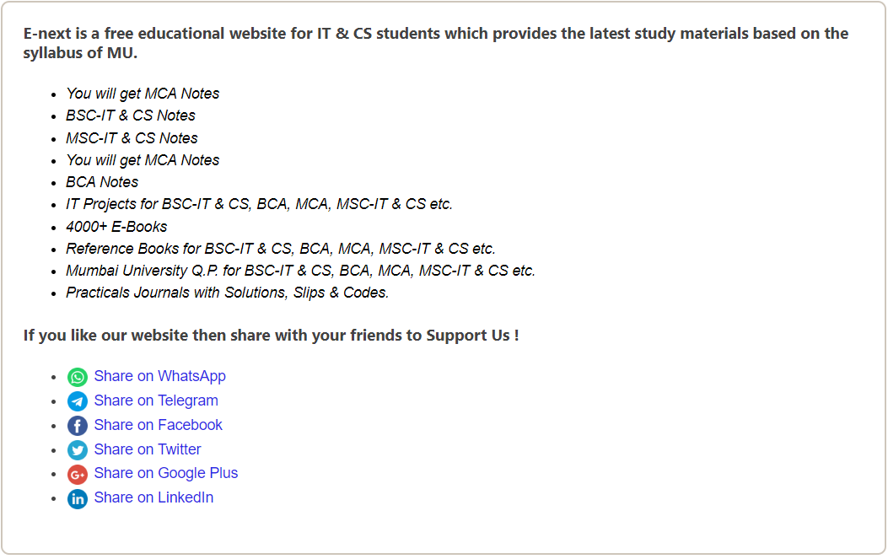
ABOUT PAGE

CLICK Here then which page open and design of that page

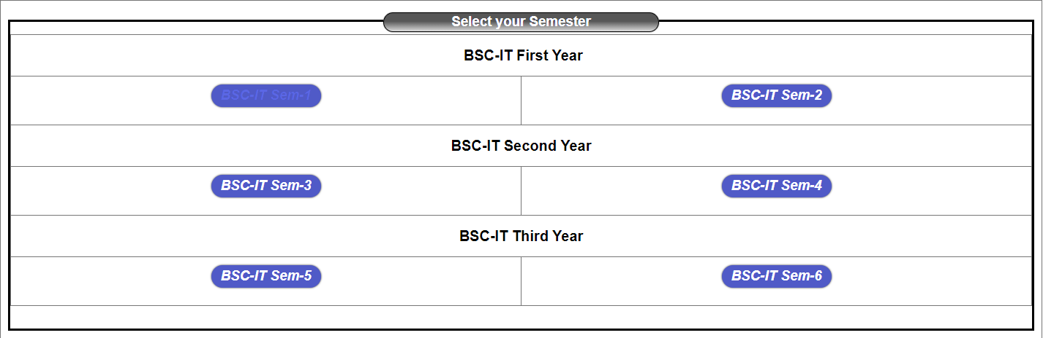

Project ideas links
http://tutorio.frontendmatter.com/demos.html
http://preview.themeforest.net/item/tutorio-education-platform-and-learning-management-system/full_screen_preview/23205024
https://www.geeksforgeeks.org/create-a-product-detail-page-template-using-html-and-css/

https://bolt.new/~/sb1-yspbo9xu

